LAB-6
WORKING WITH MAPPERS, SPLITS AND N LINE MAPPER FUNCTIONS

PRIYANSHU SHARMA
15BCE1282

Question-1

Customers details(customer name, address,mobile) are maintained in a file in hdfs. Create the customer details file with 10 records and do the following:
- Use keyvalueinput format as the input format.
- Consider customer name as key. Separate the customer name and address,mobile using “,” separator in the text file. (Ex: ram,233 first street, chennai,9999967891 (or) ram,233 first street chennai 9999967891 ). Customer name is the key and Address, Mobile are the value.

CODE

import java.io.IOException;

import java.util.*;

import org.apache.hadoop.fs.Path;

import org.apache.hadoop.conf.*;

import org.apache.hadoop.io.*;

import org.apache.hadoop.mapreduce.*;

import org.apache.hadoop.mapreduce.Reducer.Context; import org.apache.hadoop.mapreduce.lib.output.*; import org.apache.hadoop.mapreduce.lib.input.*; import org.apache.hadoop.mapreduce.JobContext.*; public class OnlyMapper{
public static class Map extends Mapper<Text,Text,Text,Text> {

String c="priyanshu";

public void map(Text key, Text value, Context context) throws IOException, InterruptedException

{

String line=key.toString();

if(c.equalsIgnoreCase(line))

context.write(key,value);

}

}

public static void main(String[] args) throws Exception{ Configuration conf= new Configuration();
conf.set("mapreduce.input.keyvaluelinerecordreader.key.value.separator",",");

Job job = new Job(conf,"OnlyMapper");

job.setJarByClass(OnlyMapper.class);

job.setOutputKeyClass(Text.class);

job.setOutputValueClass(Text.class);

job.setMapperClass(Map.class); job.setInputFormatClass(KeyValueTextInputFormat.class); job.setOutputFormatClass(TextOutputFormat.class); FileInputFormat.addInputPath(job,new Path(args[0])); FileOutputFormat.setOutputPath(job,new Path(args[1])); job.waitForCompletion(true);

}

}

OUTPUT
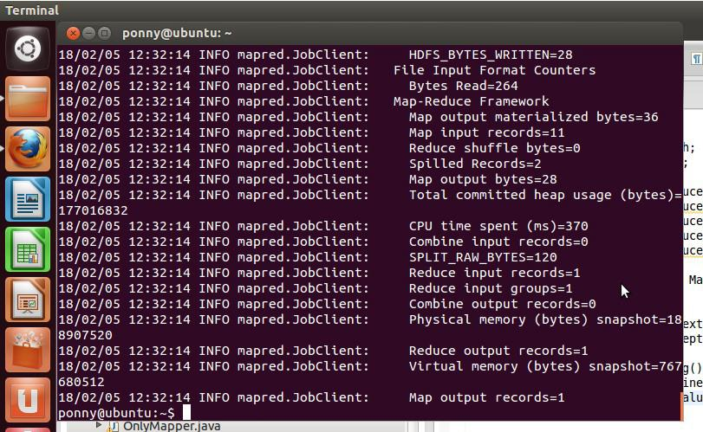
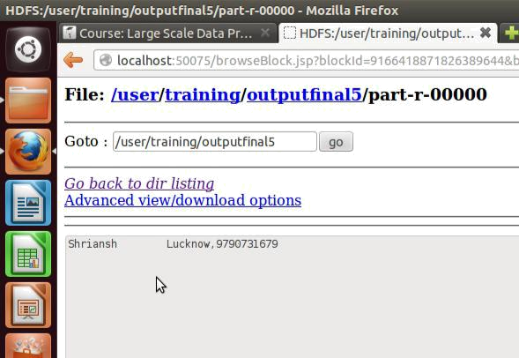

Question-2

Write the customer details in mapper with 3 lines in each mapper.Use NLineinput format.

CODE

import java.io.IOException;

import java.util.*;

import org.apache.hadoop.fs.Path;

import org.apache.hadoop.conf.*;

import org.apache.hadoop.io.*;

import org.apache.hadoop.mapreduce.*;

import org.apache.hadoop.mapreduce.Reducer.Context; import org.apache.hadoop.mapreduce.lib.output.*; import org.apache.hadoop.mapreduce.lib.input.*; import org.apache.hadoop.mapreduce.JobContext.*; public class ThreeMapper{
public static class Map extends Mapper<LongWritable,Text,LongWritable,Text> {

public void map(LongWritable key, Text value, Context context) throws IOException, InterruptedException
{

String[] line= value.toString().split(","); context.write(key,value);

}

}

public static void main(String[] args) throws Exception{ Configuration conf= new Configuration(); conf.setInt(NLineInputFormat.LINES_PER_MAP, 3); Job job = new Job(conf,"ThreeMapper");

job.setJarByClass(ThreeMapper.class);

job.setOutputKeyClass(Text.class);

job.setOutputValueClass(Text.class);

job.setInputFormatClass(NLineInputFormat.class);

job.setNumReduceTasks(0);

job.setMapperClass(Map.class);

job.setOutputFormatClass(TextOutputFormat.class);

FileInputFormat.addInputPath(job,new Path(args[0]));

FileOutputFormat.setOutputPath(job,new Path(args[1]));

job.waitForCompletion(true);

}

}

OUTPUT
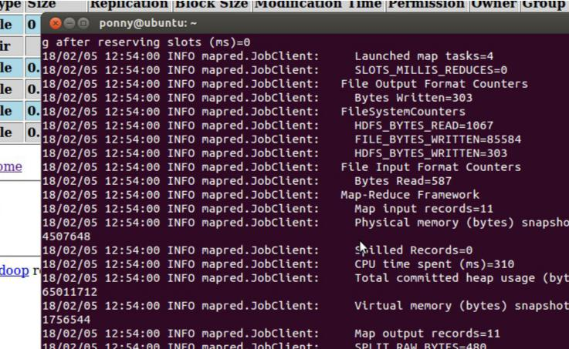
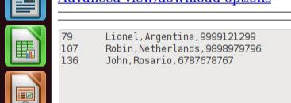
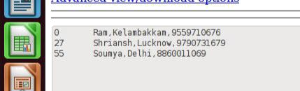

Question 3 (a)

Write the customer details using sequential file output

CODE

import java.io.IOException;

import java.util.*;

import org.apache.hadoop.fs.Path;

import org.apache.hadoop.conf.*;

import org.apache.hadoop.io.*;

import org.apache.hadoop.mapreduce.*;

import org.apache.hadoop.mapreduce.Reducer.Context; import org.apache.hadoop.mapreduce.lib.output.*; import org.apache.hadoop.mapreduce.lib.input.*;
import org.apache.hadoop.mapreduce.JobContext.*; public class SeqFile{

public static class Map extends Mapper<Text,Text,Text,Text> {

String c="vatsal";

public void map(Text key, Text value, Context context) throws IOException, InterruptedException

{

String line=key.toString();

if(c.equalsIgnoreCase(line))

context.write(key,value);

}

}

public static void main(String[] args) throws Exception{

Configuration conf= new Configuration();

conf.set("mapreduce.input.keyvaluelinerecordreader.key.value.separator",",");

Job job = new Job(conf,"SeqFile");

job.setJarByClass(SeqFile.class); job.setOutputKeyClass(Text.class); job.setOutputValueClass(Text.class); job.setMapperClass(Map.class); job.setInputFormatClass(KeyValueTextInputFormat.class); job.setOutputFormatClass(SequenceFileOutputFormat.class); FileInputFormat.addInputPath(job,new Path(args[0])); FileOutputFormat.setOutputPath(job,new Path(args[1])); job.waitForCompletion(true);

}

}

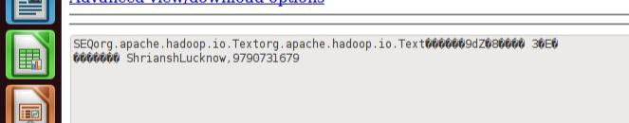

OUTPUT

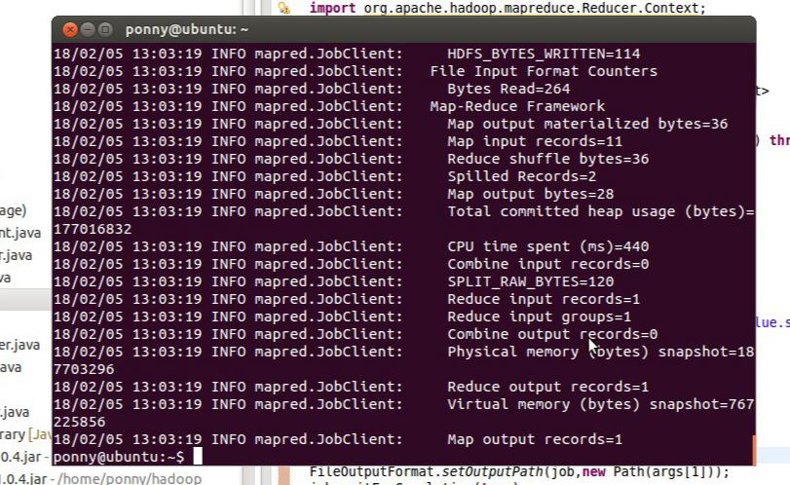

Question 3 (b)

Read using sequential file input format.

CODE

import java.io.IOException;

import java.util.*;

import org.apache.hadoop.fs.Path;

import org.apache.hadoop.conf.*;

import org.apache.hadoop.io.*;

import org.apache.hadoop.mapreduce.*;

import org.apache.hadoop.mapreduce.Reducer.Context; import org.apache.hadoop.mapreduce.lib.output.*; import org.apache.hadoop.mapreduce.lib.input.*; import org.apache.hadoop.mapreduce.JobContext.*; public class SeqFile1{
public static class Map extends Mapper<Text,Text,Text,Text> {

String c="priyanshu";

public void map(Text key, Text value, Context context) throws IOException, InterruptedException

{

String line=key.toString();

if(c.equalsIgnoreCase(line))

context.write(key,value);

}

}

public static void main(String[] args) throws Exception{

Configuration conf= new Configuration();

conf.set("mapreduce.input.keyvaluelinerecordreader.key.value.separator",",");
Job job = new Job(conf,"SeqFile1"); job.setJarByClass(SeqFile1.class); job.setOutputKeyClass(Text.class); job.setOutputValueClass(Text.class); job.setMapperClass(Map.class); job.setInputFormatClass(SequenceFileInputFormat.class); job.setOutputFormatClass(TextOutputFormat.class); FileInputFormat.addInputPath(job,new Path(args[0])); FileOutputFormat.setOutputPath(job,new Path(args[1])); job.waitForCompletion(true); }

}

OUTPUT
